UNIVERSITI MALAYSIA SARAWAK
Faculty of Computer Science and Information Technology
TMA3084 Software Engineering Laboratory | Semester 1, 2026/2027
PROJECT PROPOSAL
nägel: Nail Business Management System (NBMS)
Group Number / Name | G02-T29 / NailMuse
Lab Group / Demonstrator | Group 2 - Mr Raynold
Client / Organisation | Ms. Michelle Anak Ini, Nail Artist, nägel
Lecturer | Mdm. Nurfauza Jali
GitHub Repository | https://github.com/beanbelle/G02-T29_NailMuse_nagel.git
Version / Date | V1.0 (Original) / 17 October 2026

Team Members
No. | Name | Matric No. | TSPi Role | Signature
1 | Annabell Rinya | 102439 | 1. Team Leader  2. Customer Interface | 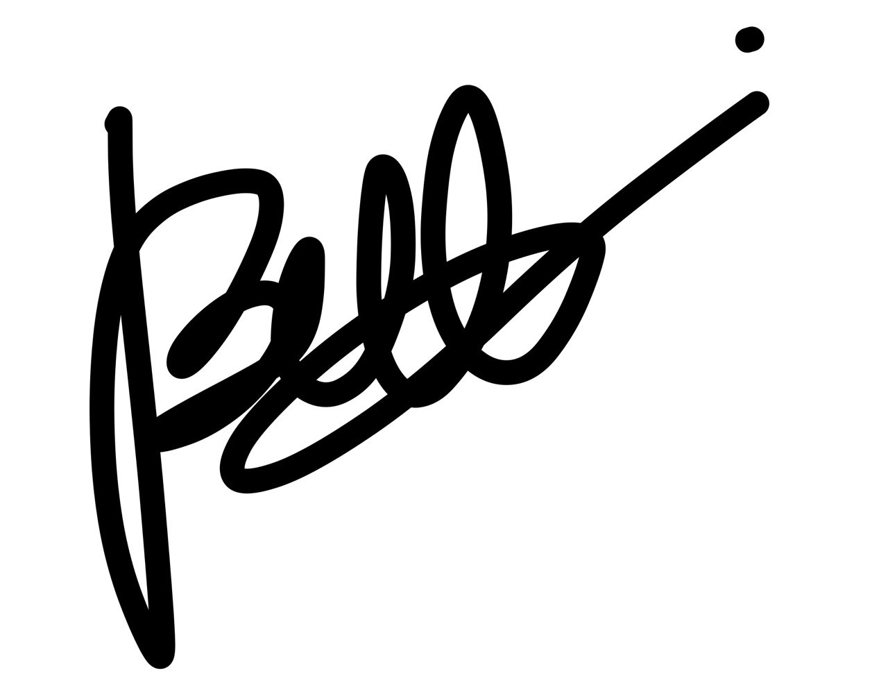
2 | Victoria Natasha Willie | 106646 | 1. Planning | 
3 | Aida Nazura binti Mohamed Amin | 103132 | 1. Design  2. Implementation
4 | Yolanda Erica Laie Anak Collin Amban | 103029 | 1. Process  2. Support
5 | ⁠Bruce Anak Ini | 97306 | 8. Quality  9. Test | 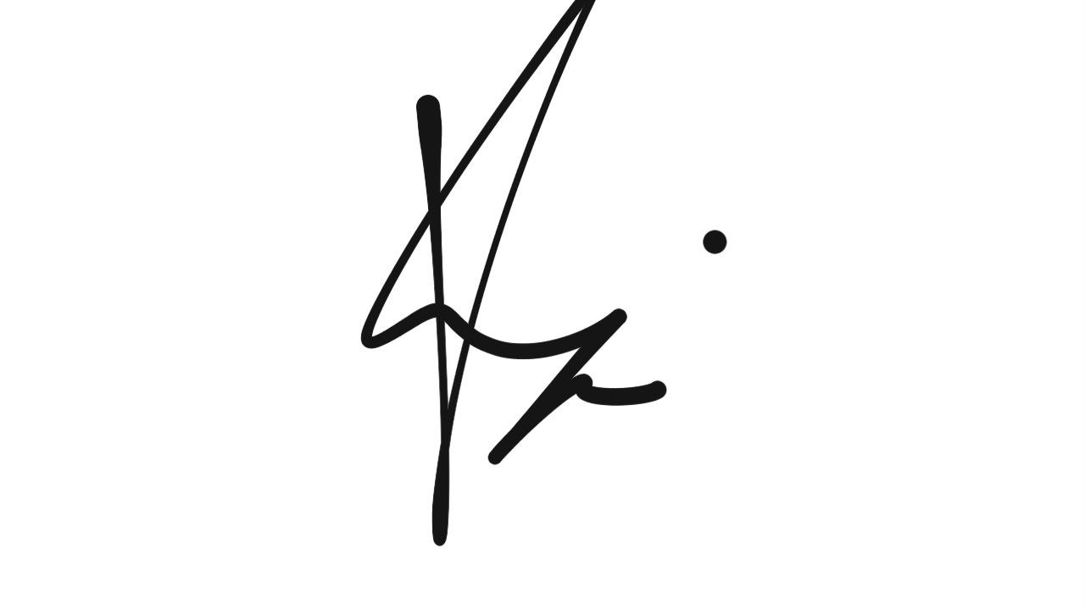
Declaration
By signing above, we certify that this proposal is our own work, that all external sources, libraries, APIs and AI-assisted content are acknowledged, and that we have not engaged in plagiarism or unauthorised collusion (Peraturan Akademik UNIMAS, Etika Akademik). AI tool usage is recorded in LOGAI.

Table of Contents

Abstract 3
1. Introduction 3
1.1 Client Background 3
1.2 Team Background 4
2. Problem Statement 4
3. Project Objectives & Success Metrics 5
4. Project Perspective 6
4.1 Target Users 6
4.2 System Context and Architecture 7
5. Project Scope 8
5.1 In Scope / Out of Scope 8
5.2 Features and User Stories 9
5.3 AI Feature 11
5.4 Non-Functional Requirements and Constraints 12
5.5 System Environment 13
6. Task Allocation & Team Contribution 14
7. Team Goals 15
8. Expected Results 15
8.1 Working System 15
8.2 Documentation and Artefacts 15
9. Project Planning 16
9.1 Methodology 16
9.2 Submission Schedule 16
9.3 Development Milestones (GitHub) 18
9.4 Risks and Assumptions 19
10. References 21
Appendix A: Client Meeting Evidence 22
Appendix B: Revision History 22

Abstract
nägel is a home-based nail salon located in Batu Kawa, Kuching, owned by Ms. Michelle Anak Ini. The business currently manages appointment bookings, deposit records, and customer reminders manually through WhatsApp and Instagram, resulting in operational inefficiencies such as last-minute cancellations, appointment disruptions caused by design changes, missed reminders, and limited inventory tracking. To address these challenges, Nail Business Management System (NBMS) is proposed as a Flutter-based Android mobile application that supports service browsing, appointment scheduling, design reference submissions, automated reminders, deposit management, and inventory monitoring. The system utilises Firebase Authentication and Cloud Firestore for backend services, while the OpenAI API provides intelligent features including nail design recommendations, price estimation, and an FAQ chatbot. Developed by a five-member team using Agile practices and TSPi role allocation, the project aims to deliver a functional and client-approved mobile solution that enhances operational efficiency and customer experience.

1. Introduction

1.1 Client Background
nägel is a home-based boutique nail salon in Batu Kawa, Kuching, established in April 2026 by Michelle Anak Ini. The salon specialises in nail care, gel polish applications, and custom nail extensions. Currently, bookings, deposits, reminders, and customer enquiries are managed manually through WhatsApp and Instagram (Anak Ini, 2026). This workflow often results in missed reminders, last-minute cancellations, design changes during appointments, and challenges in tracking inventory expenses. To address these issues, the salon reviews customer design references in advance and requires non-refundable deposits. The salon's logo is shown in Figure 1.

Figure 1: nägel's logo

1.2 Team Background

NailMuse is a team of 5 people for the group project in TMA3084 Software Engineering Lab. All the members are students of Year 3 of Software Engineering. The group’s motto is “Inspired by You, Designed For You.” The group’s logo is provided below in Figure 2.
Figure 2: NailMuse's logo

2. Problem Statement
ID | Current process / problem | Impact on client | Evidence (source)
P1 | Customers mainly book through WhatsApp and last-minute cancellations frequently occur. | Last-minute cancellations can disrupt the appointment schedule and leave the client with unexpected gaps in the client’s schedule. | Client interview (Anak Ini, 2026)
P2 | Customers often change their preferred nail designs during appointments, even after sending reference images beforehand. | The client finds it difficult to estimate the time required for appointments, which can make scheduling more difficult. | Client interview (Anak Ini, 2026)
P3 | The client manually reminds customers through WhatsApp one day before their appointment. The client sometimes forgets to send reminders. | The customer sometimes has to remind the client instead of their appointment when the client forgets to contact them. | Client interview (Anak Ini, 2026)
P4 | The client does not currently use a method to track stock and related spending. | The client may lose track of expenses and exceed their budget when purchasing supplies to cater to customer requests. | Client interview (Anak Ini, 2026)
Table 1: Summary of client problems

3. Project Objectives & Success Metrics
No. | Objective | Solves | Success metric (how we measure) | Priority
O1 | To study and analyse the client’s current appointment booking, scheduling, reminder, nail design preparation and stock & expense tracking processes to establish the system requirements. | P1, P2, P3, P4 | System requirements are documented and reviewed with the client and the SRS is approved by the agreed milestone. | High
O2 | To design and develop a Flutter-based mobile application that supports appointment booking and management, availability scheduling, customer reminders, nail design preferences and stock & expense tracking. | P1, P2, P3, P4 | All Must-have FRs pass their defined acceptance tests. | High
O3 | To integrate and evaluate AI-powered price estimation, FAQ chatbot and nail design recommendation functions to enhance customer assistance and support nail design preparation before appointments. | P2 | At least 90% of tested price estimates match expected prices; at least 90% of FAQ test questions receive correct answers; at least 80% of evaluated design recommendations meet predefined suitability criteria. | High
O4 | To test and evaluate the completed NBMS with the client to verify that the system meets its functional requirements and addresses the identified business problems. | All | At least 50 test cases are executed, test coverage reaches at least 60%, and client UAT sign-off is obtained. | Medium
Table 2: Project objectives and success metrics

4. Project Perspective

4.1 Target Users
User type | Description | Main needs / goals | Device / tech level
New customer | Finds nägel through Instagram or a friend's recommendation and then contacts the owner on WhatsApp. Usually books at the last minute (about a day before) and cares most about price. | • See services and prices before booking (FR-04)  • Book an available slot without a long WhatsApp conversation (FR-01)  • Send reference photos and preferences (FR-05)  • Get AI design ideas, a price estimate and FAQ answers (FR-08 to FR-10)  • Receive appointment reminders (FR-06) | Android smartphone (8.0 and above), basic skill, uses WhatsApp daily.
Regular customer | Returning customer who books ahead and stays for the quality, since the owner's nails last long. Mostly asks for gel and extensions (extensions are the most popular) and sometimes changes the design during the appointment. | • Book ahead using the availability calendar (FR-01)  • Keep design preferences and booking history (FR-05, FR-13)  • Decide on a design before arriving (FR-08)  • Receive appointment reminders (FR-06) | Android smartphones (8.0 and above), basic to intermediate skill.
Nail salon owner (Ms. Michelle Anak Ini) | Takes bookings and sends reminders manually on WhatsApp, sometimes forgetting them. Many customers cancel at the last minute, and she loses track of spending on special requests. | • Show an in-app calendar with available slots (FR-02)  • Confirm, reschedule and cancel appointments (FR-03)  • See the customer's design reference and add notes (FR-05, FR-12)  • Track deposits (FR-11)  • Track supplies, low-stock alerts and expenses (FR-07, FR-14) | Android smartphones (8.0 and above), moderate skill, little spare time during appointments, so screens must be simple and fast.
Table 3: Target users

4.2 System Context and Architecture

nägel: Nail Business Management System (NBMS) is a new Android application developed using Flutter to replace the client's current manual booking process conducted through WhatsApp and Instagram. The system provides role-based access for customers and the business owner, while existing channels and word-of-mouth promotion remain outside the application's scope. The system environment is outlined in Table 8, and the overall architecture is illustrated in Figure 3.
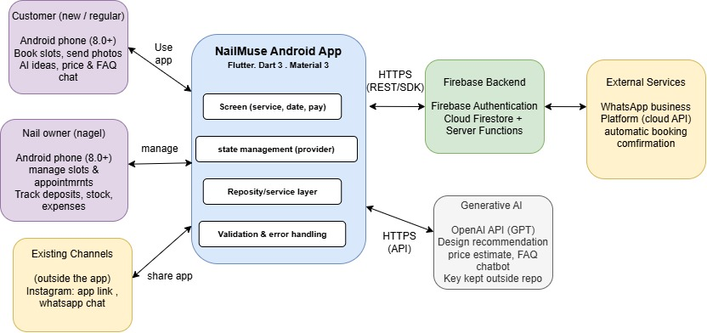
Figure 3: High-level system context and architecture of nägel: Nail Business Management System (NBMS) App
The application consists of a Flutter front end using Material 3 and Provider for state management, with Firebase Authentication and Cloud Firestore handling user accounts, appointments, services, deposits, inventory, and expenses. The OpenAI API powers three AI features: nail design recommendations, price estimation, and an FAQ chatbot. Appointment reminders and booking notifications are sent automatically, while deposit payments are made externally via QR code or bank transfer and recorded in the system. Source code is managed through GitHub with support from GitHub Actions for automated workflows.

5. Project Scope

5.1 In Scope / Out of Scope
In scope (will deliver this semester) | Out of scope (will not deliver)
Flutter-based mobile application for customers and client. | Online payment gateway and in-app payment processing.
Appointment booking and appointment management. | AI-generated nail design images.
Availability calendar for viewing and managing available appointment slots.
Nail service catalogue displaying available services and prices.
Submission of nail design, reference images and customer preferences.
Appointment reminders for customers.
Stock and expense tracking for nail supplies.
AI-powered price estimation based on selected nail services.
AI FAQ chatbot for answering customer questions.
AI nail design recommendations based on customer preferences and the business's available services.
System testing and evaluation.
Table 4: Scope boundary

5.2 Features and User Stories
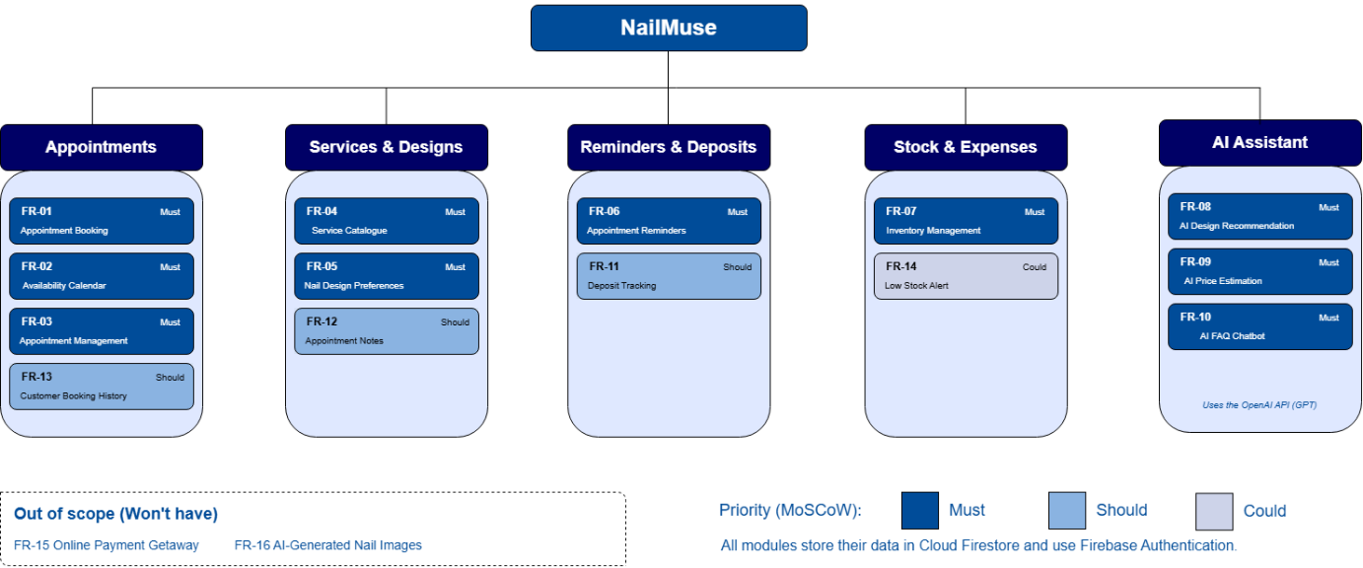
Figure 4: System Modules Diagram
Figure 4 groups the 16 requirements in Table 5 into five modules.

FR-ID | Module | User story (As a … I want … so that …) | Priority
FR-01 | Appointment Booking | As a customer, I want to book an available appointment slot based on the nail artist's schedule so that I can secure my preferred service and time. | Must
FR-02 | Availability Calendar | As a nail business owner, I want to view and update my available appointment slots so that customers can see when I am available | Must
FR-03 | Appointment Management | As a nail business owner, I want to view, confirm, reschedule and cancel customer appointments so that I can efficiently manage my daily workload. | Must
FR-04 | Service Catalogue | As a customer, I want to view available nail services and their prices so that I can choose a suitable service before booking. | Must
FR-05 | Nail Design Preferences | As a customer, I want to upload nail design reference images and specify my preferences (colour, style, shape, and occasion) so that the nail artist can better understand my desired look before the appointment. | Must
FR-06 | Appointment Reminders | As a customer, I want to receive appointment reminders and notifications so that I do not miss my scheduled booking. | Must
FR-07 | Inventory Management | As a nail business owner, I want to record and monitor nail supplies and materials so that I can identify low-stock items before accepting customer bookings. | Must
FR-08 | AI Nail Design Recommendation | As a customer, I want AI to recommend nail designs based on my preferences and the business's available services so that I can choose a suitable design before my appointment. | Must
FR-09 | AI Price Estimation | As a customer, I want to receive an estimated price based on my selected nail services so that I can understand the expected cost before booking. | Must
FR-10 | AI FAQ Chatbot | As a customer, I want to ask questions about the nail business and receive answers based on the information provided so that I can find relevant information conveniently. | Must
FR-11 | Deposit Tracking | As a nail business owner, I want to record deposit payment status for appointments so that I can track which customers have paid their deposits. | Should
FR-12 | Appointment Notes | As a nail business owner, I want to add notes to appointments so that I can remember specific customer requests and design details. | Should
FR-13 | Customer Booking History | As a customer, I want to view my previous and upcoming appointments so that I can refer to my booking history. | Should
FR-14 | Low Stock Alert | As a nail business owner, I want to receive alerts when supplies fall below a specified quantity so that I can plan to replenish them. | Could
FR-15 | Online Payment Gateway | As a customer, I want to pay through the application so that I can complete payments online. | Won’t
FR-16 | AI-Generated Nails Images | As a customer, I want AI to generate new nail design images so that I can visualise customised designs. | Won’t
Table 5: Features and user stories

5.3 AI Feature
Item | Description
AI capability | Conversational AI Chatbot (FAQ Assistance) and Personalised Nail Design Recommendation
User value | Helps customers obtain instant answers to common questions and discover suitable nail designs based on their preferences. It reduces repetitive enquiries and consultation workload for the nail artist while improving customer decision-making.
Input → Output | Input: Customer questions, preferred colors, nail style, nail shape, occasion, budget, and optional reference images.  Output: Relevant answers to FAQs, service information, price estimation, booking guidance, and personalised nail design recommendations.
AI service / API | OpenAI API (GPT-based conversational and recommendation engine)
Constraints | API key security, API usage cost, internet dependency, response latency, and customer data privacy.
Table 6: AI feature summary

5.4 Non-Functional Requirements and Constraints
NFR-ID | Category | Requirement / constraint | Target
NFR-01 | Performance | Main screens and booking pages should load quickly. | ≤ 3 seconds on a stable internet connection
NFR-02 | Security | API keys and customer data must be protected from unauthorized access. | 0 API keys exposed in source code repository
NFR-03 | Availability | The application should be accessible whenever customers need to make bookings or inquiries. | 99% service availability
NFR-04 | Usability | Customers should be able to complete a booking without extensive guidance. | Appointment booking completed within 5 minutes
NFR-05 | Compatibility | The application should support commonly used Android devices. | Android 8.0 and above
NFR-06 | AI Response Time | The AI chatbot and recommendation feature should provide responses promptly. | Average response time ≤ 5 seconds
Table 7: Non-functional requirements and constraints

5.5 System Environment
Layer | Technology / tool | Justification
Mobile app | Flutter (Dart 3), Material 3 | Course requirement; enables rapid cross-platform mobile development with a modern UI framework.
State management | Provider | Lightweight, easy to learn, and suitable for managing application state such as user authentication, appointments, and service data.
Backend / database | Firebase Authentication, Cloud Firestore | Provides secure user authentication, real-time database capabilities, and seamless integration with Flutter.
AI service | OpenAI API (GPT) | Powers the AI chatbot for customer support and nail design recommendations based on customer preferences.
Version control & CI | GitHub, GitHub Actions | Course requirement; supports collaborative development, source code management, and automated testing workflows.
Target devices | Android 8.0 and above | Supports the majority of Android smartphones used by customers and the nail business owner.
Table 8: System environment

6. Task Allocation & Team Contribution
Member | TSPi role | Owned features (FR-IDs) | Other responsibilities / contribution
Annabell Rinya | Team Leader & Client Interface | FR-01, FR-06, FR-11 | Lead team meetings, track team goals, communicate with the client, record meeting notes, coordinate system integration and milestones.
Victoria Natasha Willie | Planning Manager | FR-02, FR-03, FR-12 | Estimate tasks, track sprint schedules, manage GitHub issue assignments and boards, maintain project planning records.
Bruce Anak Ini | Quality & Test Manager | FR-04, FR-05, FR-13 | Define methodology and identify risks, develop at least 50 test cases, monitor test coverage (target ≥60%), manage GitHub Actions CI/CD, maintain LOGD, LOGTEST and LOGT.
Aida Nazura binti Mohamed Amin | Design & Implementation Manager | FR-07, FR-14, FR-09 | Oversee code design and modularity, lead architectural reviews, enforce pull-request review rules, support Flutter architecture.
Yolanda Erica Laie Anak Collin Amban | Process & Support Manager | FR-08, FR-10, FR-15, FR-16 | Maintain build tools, manage API keys and environment secrets, maintain the LOGAI audit log, support backend and AI integration.
Table 9: Task allocation and contribution

7. Team Goals
No. | Team goal | Measure
G1 | Produce a quality product | All Must-have FRs pass; CI green on main
G2 | Run a productive, well-managed project | Every milestone delivered on time
G3 | Every member contributes fairly | Each member merges ≥1 Pull Request per sprint (or per 2 weeks)
G4 | Keep the client engaged | Client meeting at least every 2 weeks
Table 10: Team goals

8. Expected Results

8.1 Working System
From the user’s perspective, nägel: Nail Business Management System (NBMS) is a mobile application that simplifies nail salon bookings and design planning. Customers can browse services, view available slots, upload design references, and receive appointment reminders, while the owner can manage bookings, deposits, inventory, and expenses. The app also integrates an AI-powered virtual assistant using the OpenAI API to provide FAQ support, nail design recommendations, and price estimations. Project success will be measured by the delivery of a signed APK, successful testing, complete documentation, and client acceptance through UAT.

8.2 Documentation and Artefacts
Deliverable | Submitted with
Project Proposal (original) | Proposal Submission (Week 4)
Revised Proposal and Software Requirements Specification (SRS) | Initial Report (Week 9)
Runnable prototype (4–5 screens), tagged release | Demo 1 (Week 9)
Software Design Specification (SDS), test plan and results (LOGTEST), user manual, maintenance plan, client acceptance form | Final Report (Week 13)
Release APK, demo video (5–10 min), presentation slides | Final Demo 2 (Week 14)
GitHub repository and complete project file | e-Archive (Week 15)
TSPi forms (LOGT, LOGD, LOGAI, SCHEDULE, SUMP, SUMQ, SUMS, SUMTASK, WEEK, PEER) and meeting minutes | Ongoing; compiled in Final Report
Table 11: Deliverables

9. Project Planning

9.1 Methodology
The nägel: Nail Business Management System (NBMS) project uses an Agile methodology to support iterative development and continuous client feedback. TSPi complements this approach by defining team roles, task ownership, and quality objectives. GitHub will be used for version control, issue tracking, code reviews, and workflow automation through GitHub Actions. Regular testing, milestone reviews, and client evaluations will be conducted to ensure software quality and project success.

9.2 Submission Schedule
Phase | Deliverable | Week | Due
Phase 1: Planning & Development | Proposal Submission | 4 | 9 Oct 2026
 | Proposal Presentation | 5 | 19 – 23 Oct 2026
 | Initial Report | 9 | 16 Nov 2026
 | Demo 1 | 9 | 16 – 20 Nov 2026
Phase 2: Finalisation & Closure | Final Report | 13 | 24 Dec 2026
 | Final Demo 2 | 14 | 28 – 31 Dec 2026
 | e-Archive | 15 | Before 10 Jan 2027
Table 12: Submission schedule

9.3 Development Milestones (GitHub)
Milestone | Week | Key output | Status
M1 – Scope & Requirements | 4 – 5 | GitHub repo, issue board, CI file; proposal and initial SRS in /docs | Completed
M2 – Design & Prototype | 9 | SDS draft, 4–5 screen prototype, green CI, v0.2.0 tag | Not started
M3 – Product & Verification | 13 | ≥50 tests, ≥60% coverage, AI feature working | Not started
M4 – Final Release & Acceptance | 15 | Release APK v1.0.0, client sign-off, e-Archive | Not started
Table 13: Development milestones
Task ID | Task / Deliverable | Owner | W1 | W2 | W3 | M1 | W4 | W5 | W6 | W7 | W8 | M2 | W9 | W10 | W11 | W12 | M3 | W13 | W14 | M4 | W15
T-101 | Repository & Controls | Annabell
T-102 | Client Requirements | Annabell
T-103 | Requirements SRS | Victoria
T-104 | Project Schedule | Bruce
T-105 | Architecture & UI | Aida
T-106 | AI Feature & NFR | Yolanda
T-201 | App Scaffolding | Aida
T-202 | User Auth & Reminders | Annabell
T-203 | Slot Calendar & Appointment Mgmt | Victoria
T-204 | Inventory/Stock Management | Aida
T-205 | Appointment Mgmt & Design Upload | Bruce
T-301 | AI Recommendation & FAQ | Yolanda
T-302 | Deposit Status Tracking | Annabell
T-303 | Appointment Notes | Victoria
T-304 | Customer Booking History | Bruce
T-305 | AI Pricing & Low Stock Alerts | Aida
T-306 | Testing & CI/CD | Bruce
T-307 | Audit & Environment | Yolanda
T-401 | Release & Acceptance | Annabell
Figure 5: Gant chart of tasks, weeks and milestone. (Keyword: T-101 represents Task 1 of Milestone 1)

9.4 Risks and Assumptions
ID | Risk / assumption | Likelihood | Impact | Mitigation
R1 | The client may be unavailable for meetings or provide feedback later than expected, delaying requirement clarification and acceptance testing. | Medium | High | Schedule client meetings in advance, agree on consultation dates, and use online communication as a fallback. Record decisions and feedback in meeting minutes.
R2 | The selected AI API may exceed its free-tier usage limits, incur additional costs, or become temporarily unavailable. | Medium | High | Select an AI service with suitable usage limits, monitor API consumption, protect API credentials, and allow users to browse the nail service catalogue if AI recommendations are unavailable.
R3 | Team members may have limited experience with Flutter, backend integration, AI APIs, or automated testing, causing development delays or technical defects. | High | High | Use official documentation, share technical knowledge among team members, divide tasks according to skills, and develop and test features incrementally.
R4 | Changes to customer nail design preferences or appointment requirements may result in changing requirements and additional development work. | High | Medium | Confirm essential requirements with the client early, prioritise features using MoSCoW, document requested changes, and assess their impact on the project schedule before implementation.
R5 | Customer information or AI API credentials may be exposed through insecure data storage or incorrect application configuration. | Medium | High | Apply appropriate backend access controls, keep API credentials out of public source code, store secrets securely, and test security rules before deployment
Table 14: Risks and assumptions

10. References
Anak Ini, M. (2026, October 7). Client requirements and operational workflow interview for nägel nail salon [Personal communication].
Firebase. (2026). Firebase documentation and Cloud Firestore reference. Google. https://firebase.google.com/docs
Flutter Team. (2026). Flutter documentation: Building cross-platform applications with Dart 3. Google. https://docs.flutter.dev
Humphrey, W. S. (2000). Introduction to the Team Software Process (TSPi). Addison-Wesley Professional.
OpenAI. (2026). OpenAI API reference: GPT models for conversational recommendation engines. https://platform.openai.com/docs

Appendix A: Client Meeting Evidence

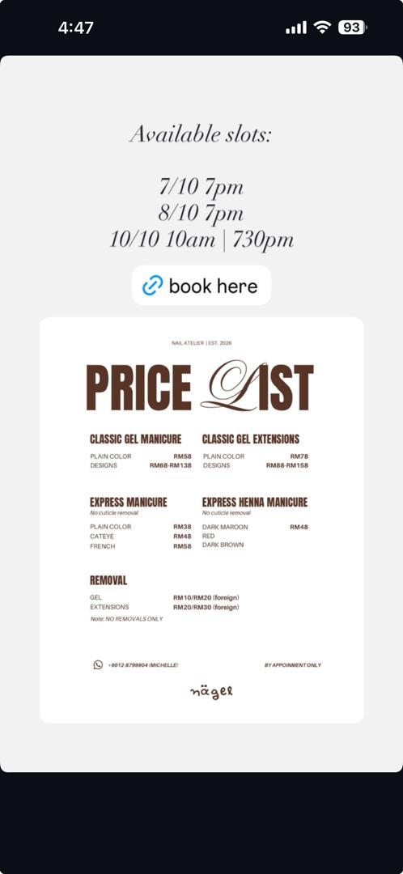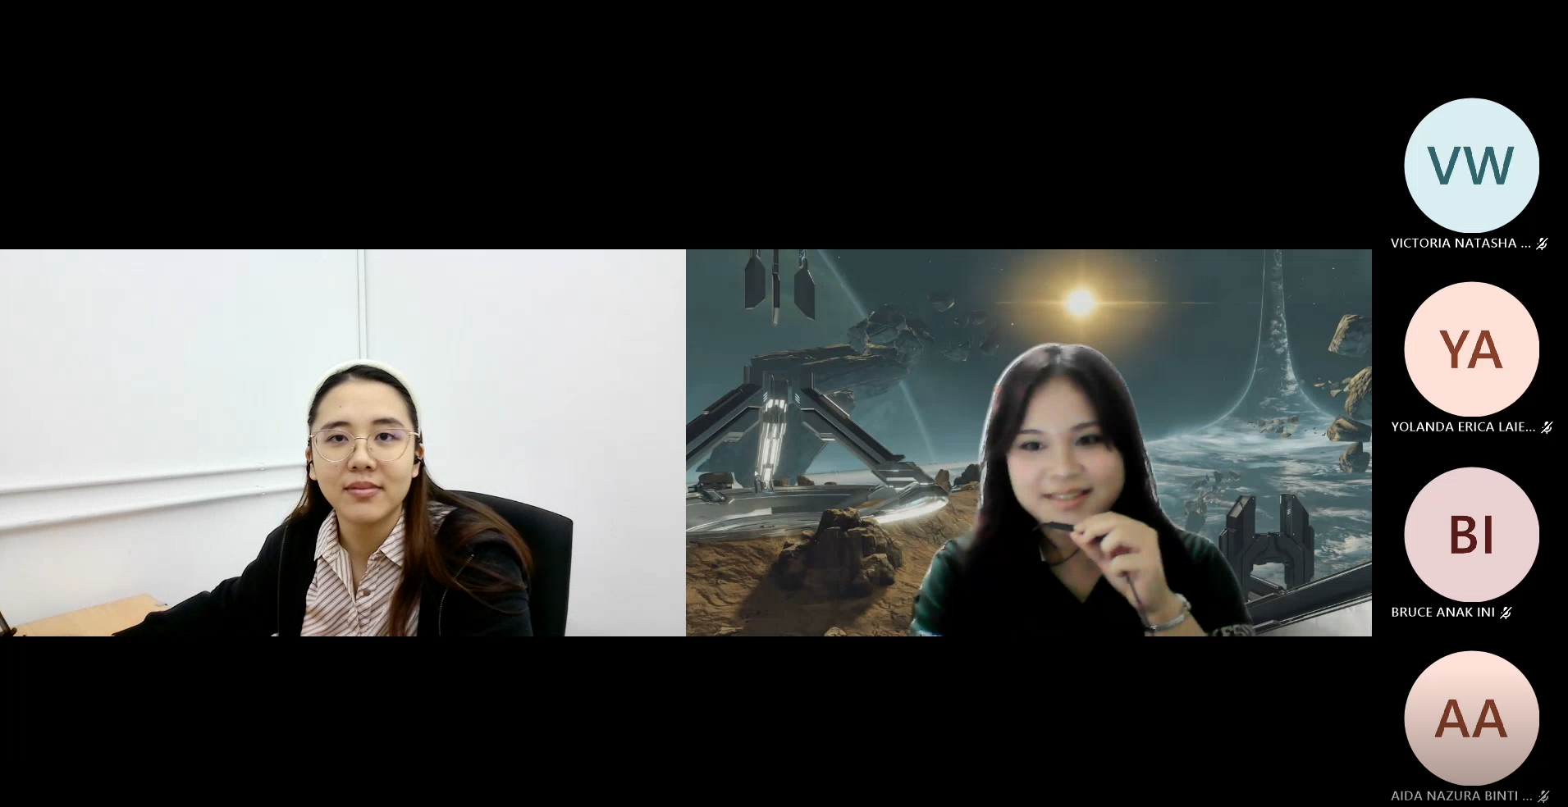

Attendees
- Annabell Rinya (102439)
- Aida Nazura (103132)
- Yolanda Erica Laie (103029)
- Victoria Natasha (106646)
- Bruce (97306)
- Ms. Michelle (Client)

Meeting Context:
Elicitation interview conducted with Ms. Michelle Anak Ini on October 7, 2026 (Anak Ini, 2026).

Meeting Summary

- Booking & Scheduling: Clients currently book mostly via WhatsApp (and occasionally social media). New clients frequently book at the last minute (a day prior), whereas regular clients book in advance.
- Service Details & Operations:
  - Gel and extensions are the most requested services, with extensions being the most popular overall.
  - Customers typically send reference designs before appointments, but a major operational challenge occurs when they change their minds during the appointment, making time estimation difficult.
  - Price drives decisions for new clients, while quality and longevity keep regular clients coming back.
- Reminders & Attendance: The client manually sends WhatsApp reminders a day before appointments, but occasionally forgets, leading to clients reminding her instead.
- Sales & Inventory Tracking: Business transactions are separated into a dedicated bank account, and all payment types (cash, QR code, etc.) are accepted. However, fulfilling specific, unexpected customer requests creates friction and makes tracking expenses difficult.

Decisions Made

- Cancellation Policy: Last-minute cancellations are handled by forfeiting/burning the customer's deposit as compensation.
- App Feature Decision: An in-app calendar reminder feature will be included to display the client's availability and available booking slots clearly.

Appendix B: Revision History
Version | Date | Changes (e.g. after proposal presentation feedback) | By
1.0 | 17 October 2026 | Original submission | Annabell (102439)

Appendix C: Submission Requirements

Slide link: https://canva.link/petheea4eogz010
Youtube link: https://youtu.be/DGmZ6ekRuuo

